1. Objective of whole project.

Compare MADGE data to other machine learning algorithms like SVM and neural networks. Accuracy and speed will be the two most optimized features, with accuracy without overfitting as the most interesting piece to explore.

1. What was implemented last week.

MADGE method was used on MNIST data for various sigmas. An attached HTML will show the results. A sigma of 0.85 was found to be most optimal, with a 92.7% accuracy.

MNIST training data is not shuffled, and therefore there is no variance in accuracy for a given sigma.

Each accuracy is generated based off of the first 2000 MNIST data point samples. There are a total of 10,000 samples, but running through all 10,000 for each data point takes a significant amount of time.

1. Plans for upcoming week.

Discuss about plans moving forward and what to do with this information.

1. Objective of whole project.

Compare MADGE data to other machine learning algorithms like SVM and neural networks. Accuracy and speed will be the two most optimized features, with accuracy without overfitting as the most interesting piece to explore.

1. What was implemented last week.

Trials were conducted to classify STL-10 data. STL-10 data is split into 96 x 96 images in three layers RGB with 10 total classification categories.

Each layer was converted into a 1 x 9216 vector. Standard 80%/20% testing to training data was used.

Classification accuracy was around ~10% for each layer. Combining the layers into one 1 x 27,648 vector also yielded around 10% accuracy.

1. Plans for upcoming week.

Previous datasets had fewer dimensions. The MNIST data set only had a 28 x 28 field, or a 1 x 784. It seems like higher dimensionality could be the limiting factor to MADGE.

I propose a moving window, similar to something like the image below: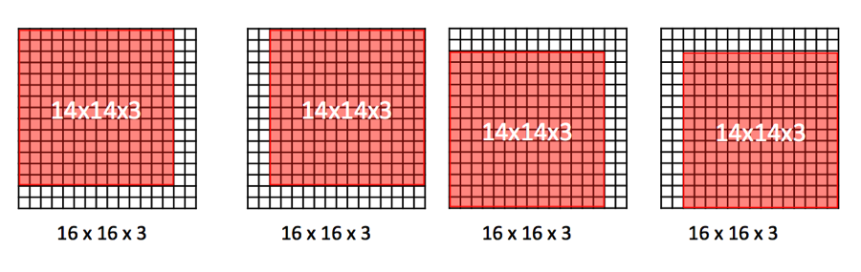

This way a smaller dimensionality is collected and classified.